Joining the College Academic Standards Subcommittee Community in Blackboard
- Go to Blackboard: https://suffolkonline.open.suny.edu
- Click on the Bb Login button
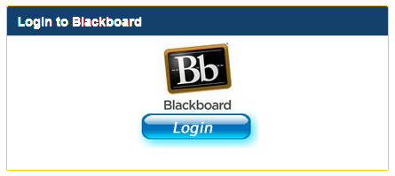
- Log in using your Suffolk username and password
- Click on the Community tab
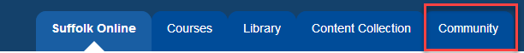
- In the Organization Search, type in ‘standards’ and click Go
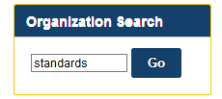
- The College Academic Standards Subcommittee should appear in the search results. Click on the down arrow that appears when you hover your curser over the Organization ID and select Enroll.
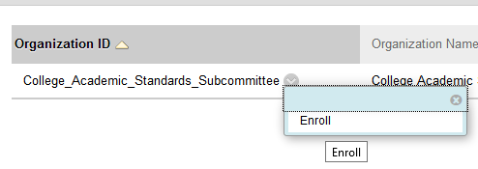
- Type in ‘academic’ in the Access Code textbox and click Submit to enroll in the community
